5.28

Sinajs is getting unreliable

Need to get 5 sec snapshot data from IB directly. Implement this today.

* Request holdings only
* Should be able to recover prices of big caps through IB, not rely on fill
* Two things to work on

1. Fill today data by IB

req1StockHistToday

1. Live 5 sec data (refer to ON HK on the bottom bar)

Req1StockLive (for live)

Stock universe:

1. For all ptf stocks first
2. For all A50 stocks (in order for index to be computable)
3. For all stocks

You need to the

**5.29**

Rolling futures

1. Orders file add date if current globalOrderMap has 1 order (first order)
2. Net delta compution, includes both front and back future.
3. How to roll futures

While rolling

* Make sure delta is correct at all times
* Short roll – like premium
* Want to know the current roll price, roll percentile

Roll mechanisms:

* Roll indicator, if ON, then start rolling
* Frontfut and backfut defintions are not changeable. (FrontFut is defined by front expiry, which is only determined by current time, if it is before 15:00 on expiry date)
* You must roll front fut into backfut.
* Roll termination: roll until frontFut size == 0
* You can point activeFut to backfut anytime. (usually happens 1~2 days before expiry). Activefut is for trading delta.

Roll Strategies:

* (TWAP) time weighted, roll 1 lot every x minutes
* Roll automatically when price is attractive
* Find out the primary exchange of ASHR (done, add primary exchange = ARCA)
* How to submit a spread order

Implement an intraday percentile trader on small sizes (the middle ground for inventory trader and percentile trader(2 days))

Long rollers are compensated.

Short rollers need to pay 40 bps to roll, showing the bearishness of the market.

After market

1. Ytd was strong, ytd’s chasers are punished today
2. Failed to rebound to ytd’s high close.
3. Work on rolling today.

5.30

5.31

Tech aspect:

- Periodic sending pnl through email

- run java program on a server and access it with phone

Trading aspect:

After a big drop, higher delta.

After a big rise, lower delta

Refine hedging scenarios.

* Hedging mainly overnight, where US is in bear market or highly volatile
* Hedging volatile sessions, can move around
* Hedging when US vol spikes up, can follow crash
* Hedging when china opens low < -1% (don’t lift hedge) can crash back into close

Lift hedge when:

1. Previously crashed -> can increase delta (not too much)

**Ytd rolling problem :**

* Lack of accumulation/decumulation tools (vwap or twap or whatever) based on some condition, ytd rolled everything at flat PD. Need to build this.
* This can be linked to PD trading.

**Intraday cover at low percentiles (only look at 1 day percentile, not 2 days)**

* Theory is the holding return is positive from open to close. (8 bps)
* Open lower by about 5 bps
* Buying at low percentiles and selling at close or selling at intraday highs.

**Overall thoughts:**

Markets are very volatile.

Overnight hedging is necessary in bear markets to avoid US’s influence on China.

Lifting some hedge after a crash.

Intraday covering at lows. (single day percentile). This is limited to 1 position testing for now.

Pnl reporting: use asterisks to separate.

Make sure every hour there is a pnl report.

During the day there should be no selling, as close > open statistically. There should be systematically delta covering.

6.1

Weekly review:

Futures: +5k

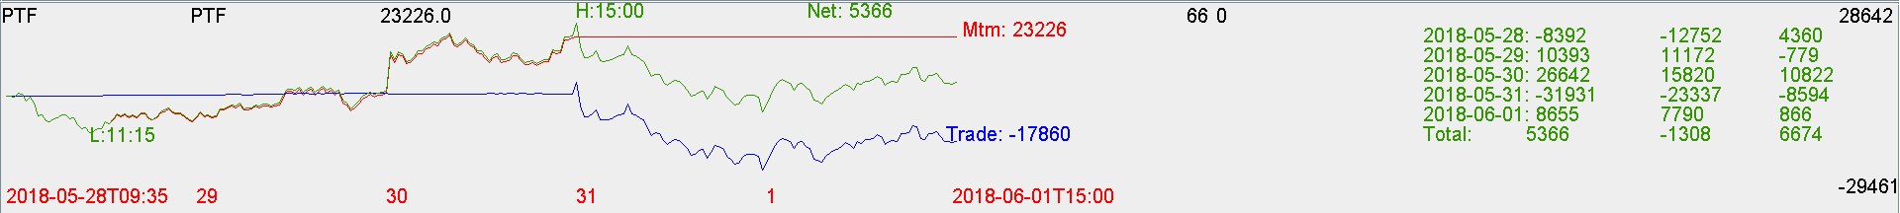

Cash : +4k

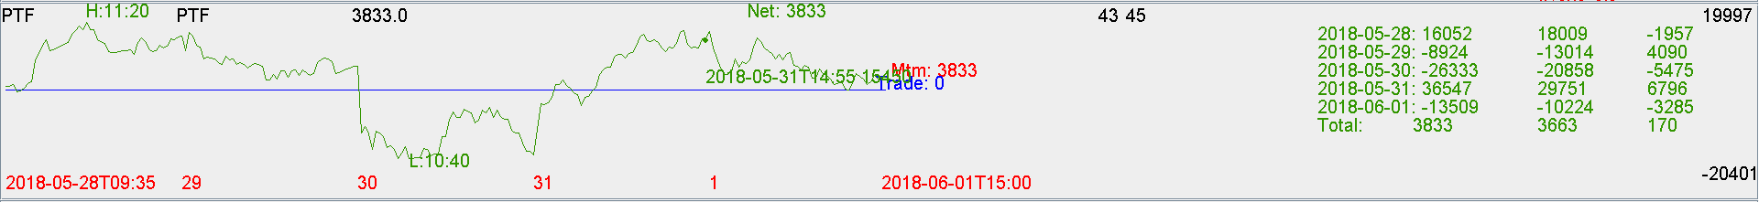

Comments and improvements:

* Percentile trading works well
* Cost 40 bps to roll until 7pm on expiry date – they wanted to rip off the short rollers until the last minute, and it flipped to positive and ended at a 50 bps premium at the next open. If you rolled early because your stock position is too big. You would be massively ripped off.
* Delta limit revised up following crash.
* Buying at discount following crash.
* Need to be comfortable with naked stock position when it is not suitable to roll
* Rolling needs to be consistent with percentile. Otherwise leave naked stock position.
* Understand your advantage is small position and ability to take risk.
* Keep trading PD+percentile with small position automatically.